
DEPARTMENTOFMATHEMATICS
PROJECT RECORD
ON
I REVOLUTION: A DATA DRIVEN EXPLORATION
OFAPPLE IPHONE IMPACT IN INDIA

- FUNDAMENTALOFDATAANALYTICS WITHTABLEAU
2023-2024
TAMILNADU SKILL DEVELOPMENT
CORPORATION, GOVERNMENT OF TAMILNADU,
NAAN MUDHALVAN PROGRAM
Submitted
By
1.ALNISHA.S (222106816)

2.EZHAKIYAMMAL.N(222106820)
3. SRI SURUTHI.E(222106828)
4.VANITHA.M(222106831)
(III B.Sc MATHEMATICS)

CERTIFICATE
THIS IS TO CERTIFY THAT THE PROJECT IS TITLED I REVOLUTION: A DATA DRIVEN EXPLORATION OF APPLE IPHONE IMPACT IN
INDIA THIS PROJECT IS SUBMITTED BY ALNISHA.S (222106816),
EZHAKIYAMMAL.N (222106820), SRI SURUTHI.E (222106828),VANITHA.M
(222106831) OF III B.SC MATHEMATICS, DR. MGR JANAKI COLLEGE OF ARTS AND SCIENCE FOR WOMEN, CHENNAI IN FULFILLMENT OF THE REQUIREMENTS FOR TAMILNADU SKILL DEVELOPMENT CORPORATION, GOVERNMENT OF TAMIL NADU, NAAN MUDHALVAN PROGRAM. THIS
PROJECT WAS AN AUTHENTIC WORK DONE BY HIM UNDER MY
SUPERVISION AND GUIDANCE.



TABLE OF CONTENTS
S.NO | CONTENTS | PAGE NO
1 | INTRODUCTION | 3
 | 1.1 OVERVIEW | 3
 | 1.2 PURPOSE | 3
2 | PROBLEM DEFINITION & DESIGN THINKING | 4
 | 2.1 EMPATHY MAP | 4
 | 2.2 IDEATION & BRAINSTORMING MAP | 5
3 | RESULT | 6
4 | ADVANTAGES & DISADVANTAGES | 13
 | 4.1ADVANTAGES | 13
 | 4.2 DISADVANTAGES | 13
5 | APPLICATIONS | 14
6 | CONCLUSION | 15
7 | FUTURE SCOPE | 16
8 | REFERENCE | 17
9 | VIDEO | 18
I REVOLUTION:ADATADRIVEN EXPLORATION OFAPPLE IPHONE IMPACT IN INDIA
1.INTRODUCTION 1.1 OVERVIEW
About the report
The invention of the iPhone has affected people's lives and how they do
things. It has also set in motion a few trends that wouldn't have been possible without iPhone. Apple has revolutionized communication, playing games, watching movies, listening to music, and more.Apple has been selling iPhone in India since 2008, but it is only in recent years that the company has shifted strategy to make iPhone more accessible through various offers and promotions, which has contributed significantly to the increase in market share
1.2 PURPOSE
Apple's iPhone was a great success because it made communication
more convenient than ever before. It allowed people to access information through digital media on their phones Apple's iPhone is an amazing invention that allows users to get all of their needs done in one device With so many people using iPhone it comes with the ability to use social media in an easier way that on the web. Social media influences our society in positive and negative ways. A beneficial way I have experienced is that it is an easy way to stay in touch with friends and family that are near and far.

2.PROBLEM DEFINITION & DESIGN THINKING

2.1 EMPATHY MAP
An empathy map is a collaborative tool teams can use to gain a deeper insight into their customers. Much like a user persona, an empathy map can represent a group of users, such as a customer segment. The empathy map was originally created by Dave Gray and has gained much popularity within the agile community Assemble your team and have them bring any personas, data, or insights about the target of your empathy map. Print out or sketch the empathy map template on a large piece of paper or whiteboard. Hand each team member sticky notes and a marker. Each person should write down their thoughts on stickies. Ideally everyone would add at least one sticky to every section. You might ask questions, such as:
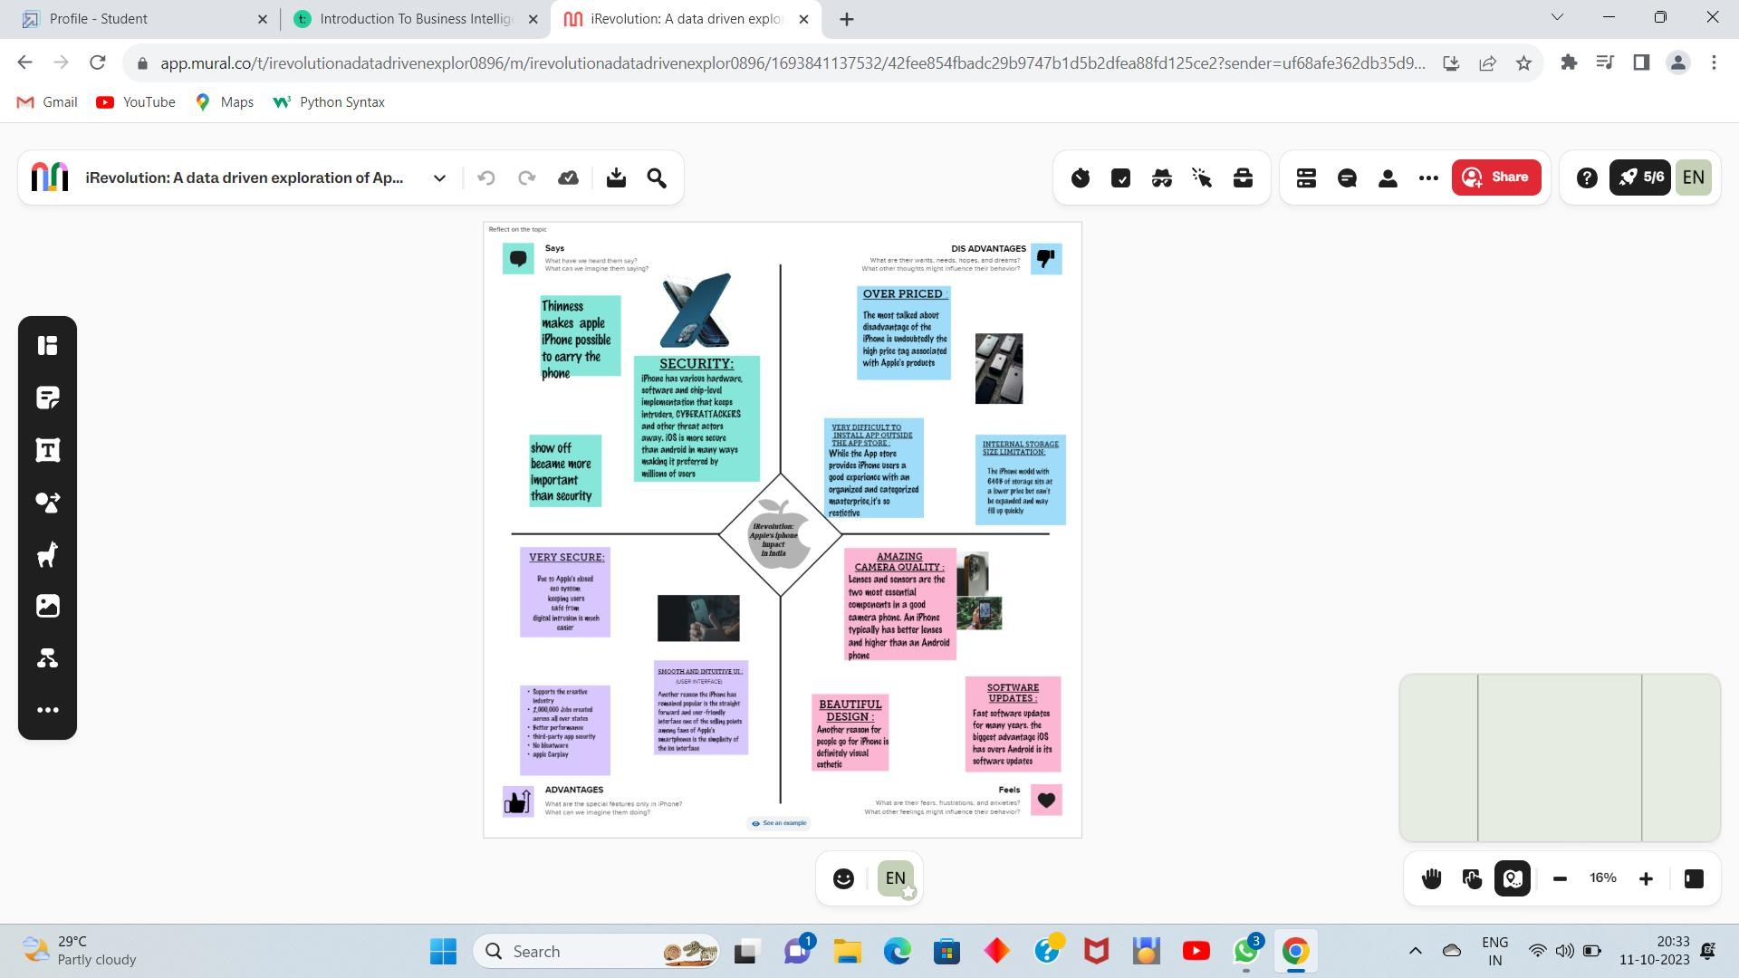

2.2 IDEATION & BRAINSTORMING MAP
Brainstorming is a method of generating ideas and sharing knowledge to solve a particular commercial or technical problem, in which participants are encouraged to think without interruption. Brainstorming is a group activity where each participant shares their ideas as soon as they come to mind. At the conclusion of the session, ideas are categorized and ranked for follow-on action.When planning a brainstorming session it is important to define clearly the topic to be addressed. A topic which is too specific can constrict thinking, while an ill-defined topic will not generate enough directly applicable ideas. The composition of the brainstorming group is important too. It should include people linked directly with the subject as well as those who can contribute novel and unexpected ideas. It can comprise staff from inside or outside the organization.
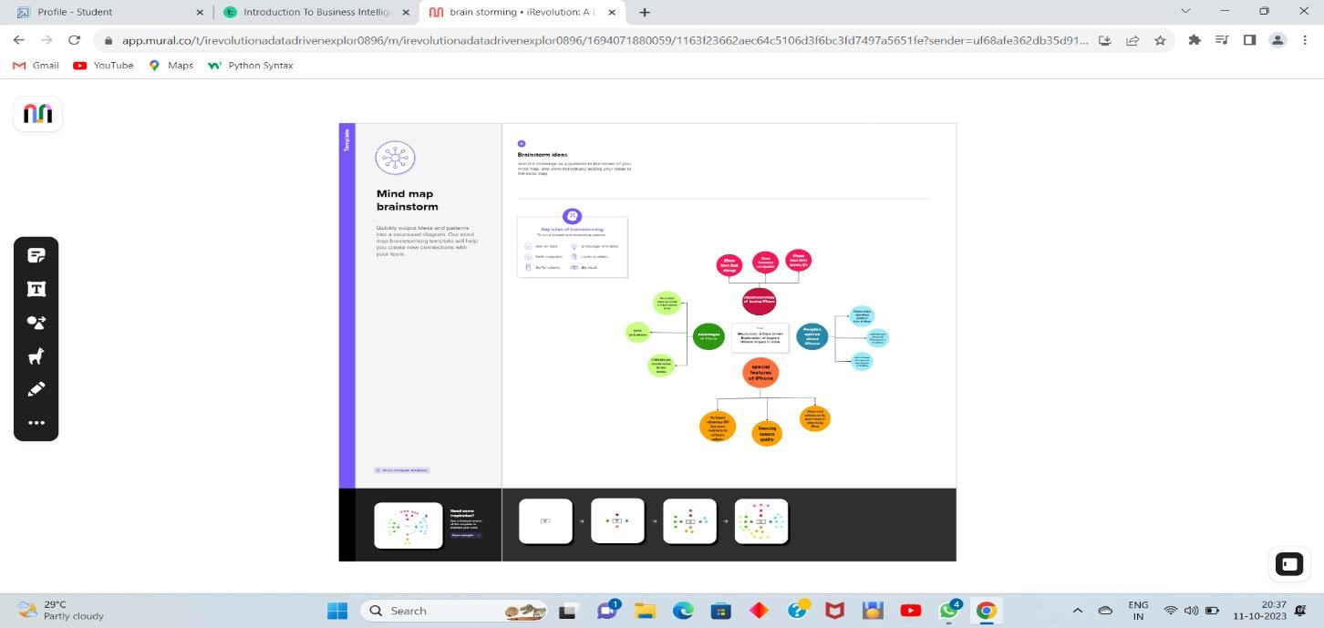

3. RESULT
KPI
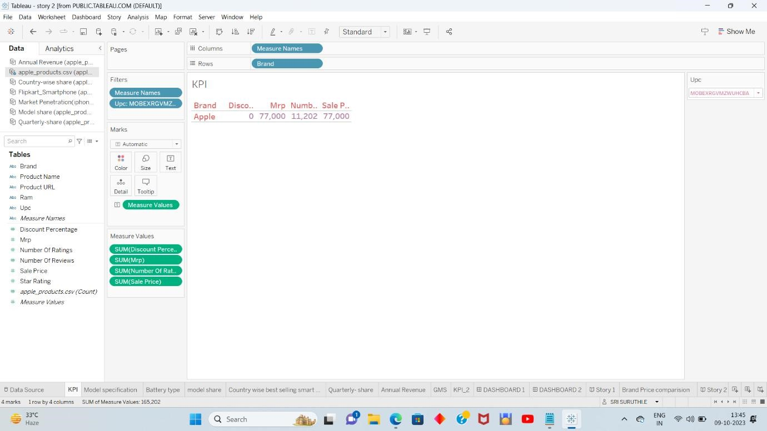
MODEL SPECIFICATION
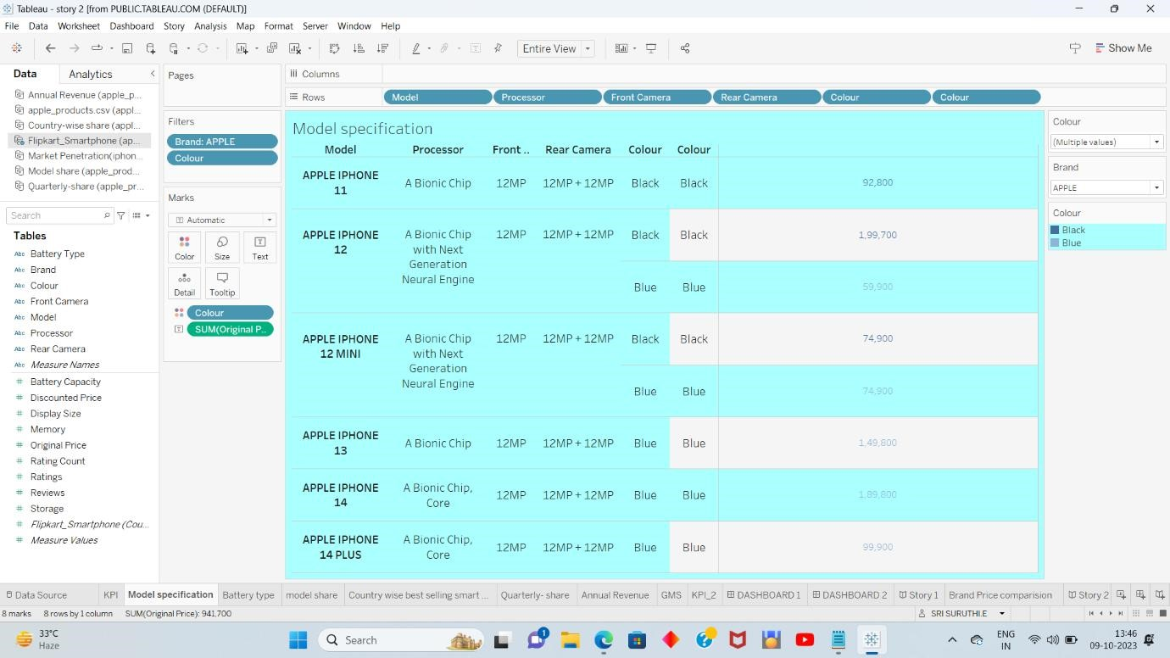
BATTERYTYPE
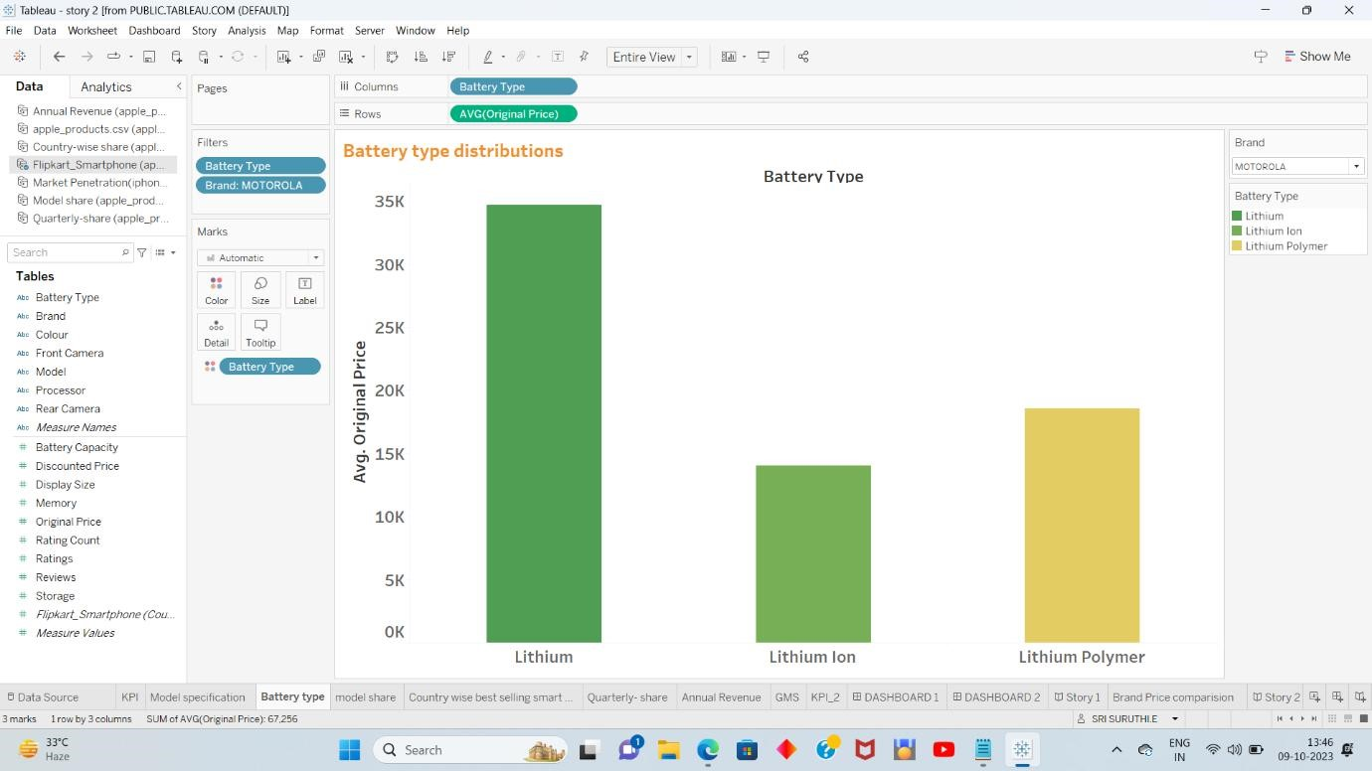
MODEL SHARE
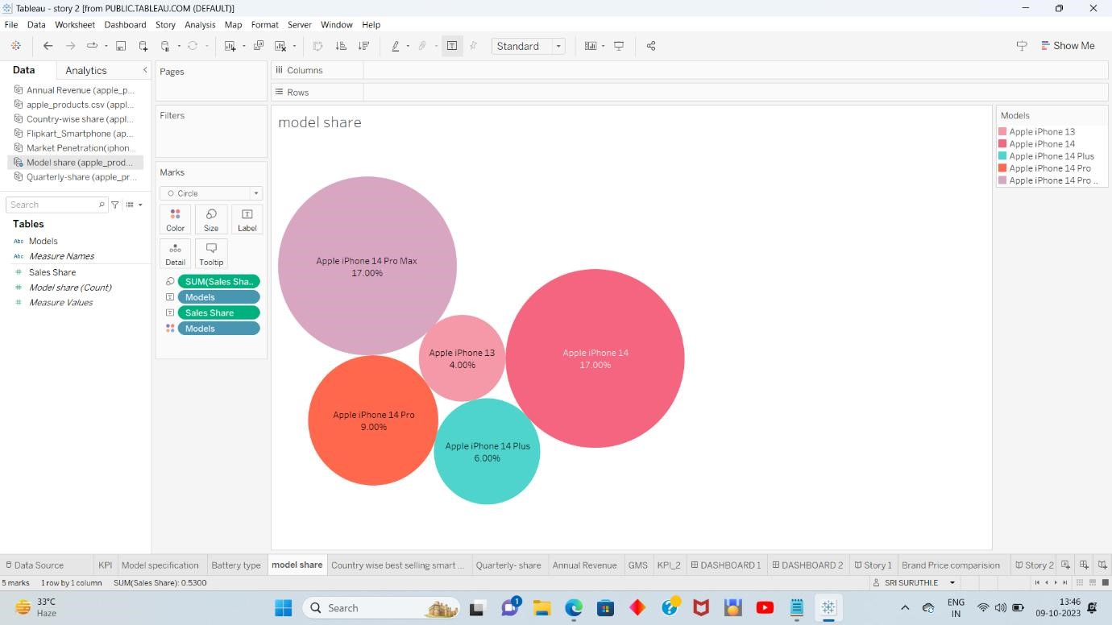
COUNTRYWISE BEST SELLING SMART PHONES
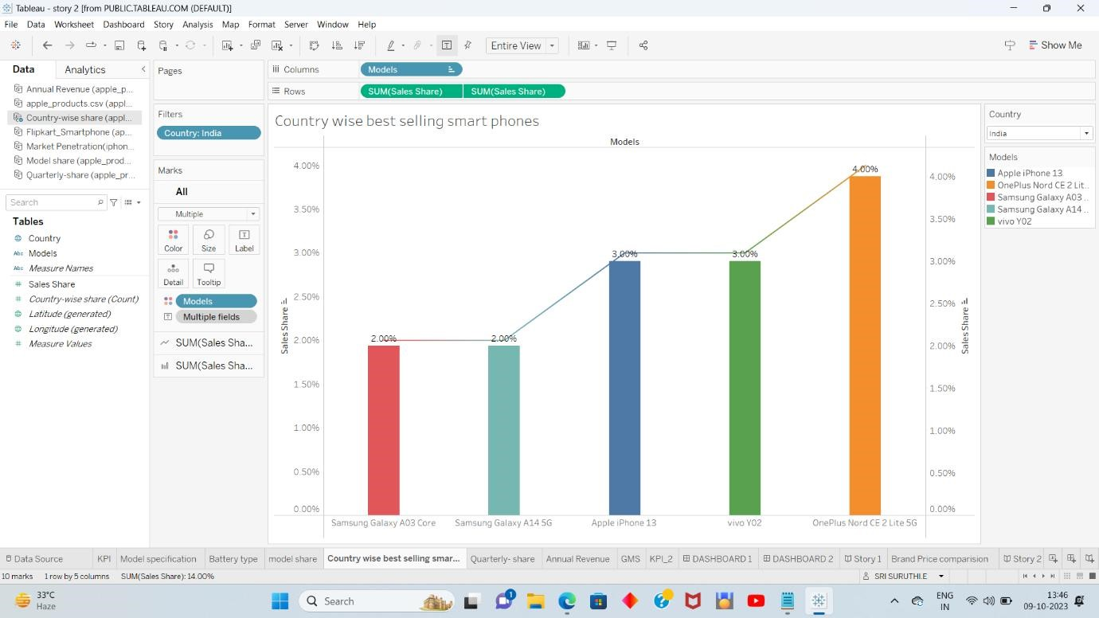
QUARTELY-SHARE
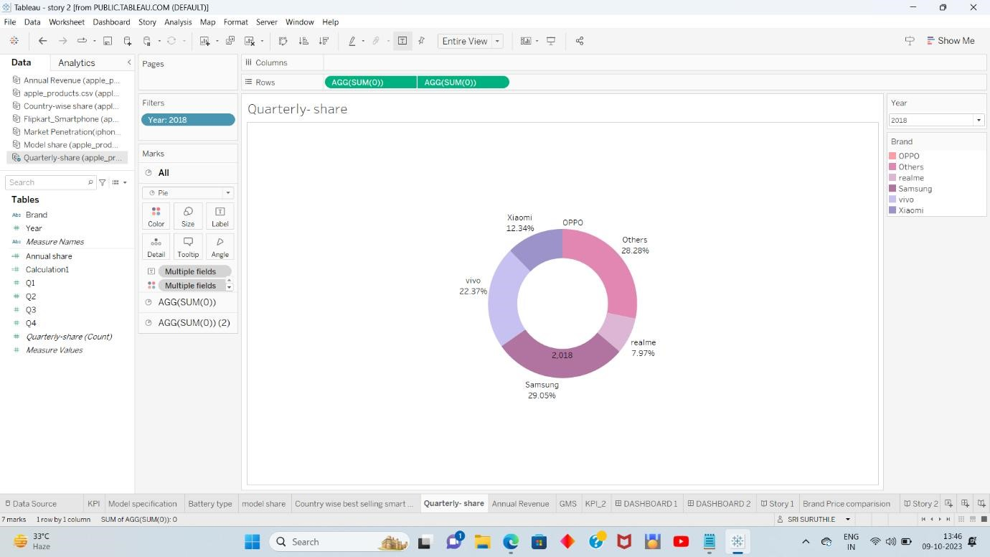
ANNUAL REVENUE
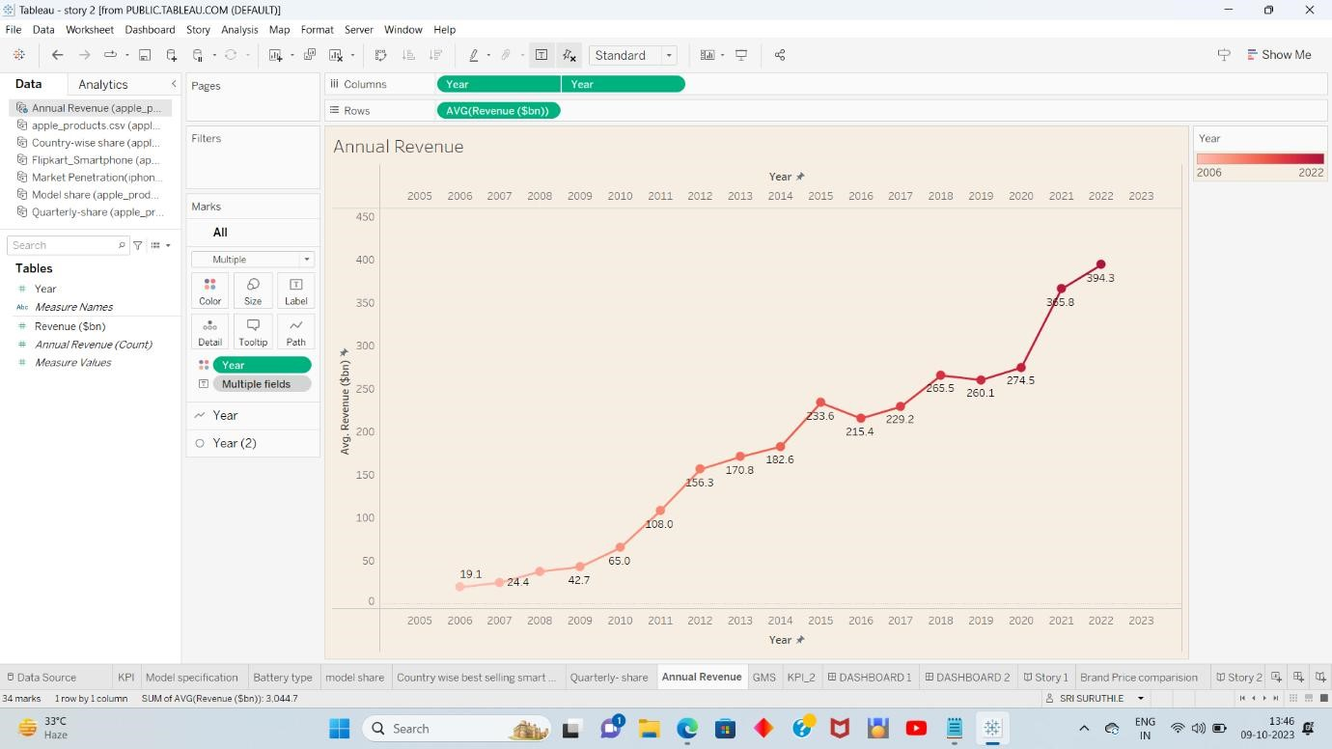
GOBAL MARKET SHARE
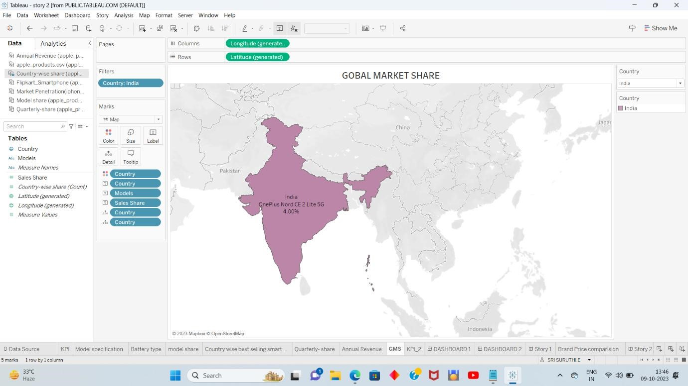
KPI-2

BRAND PRICE COMPARISON
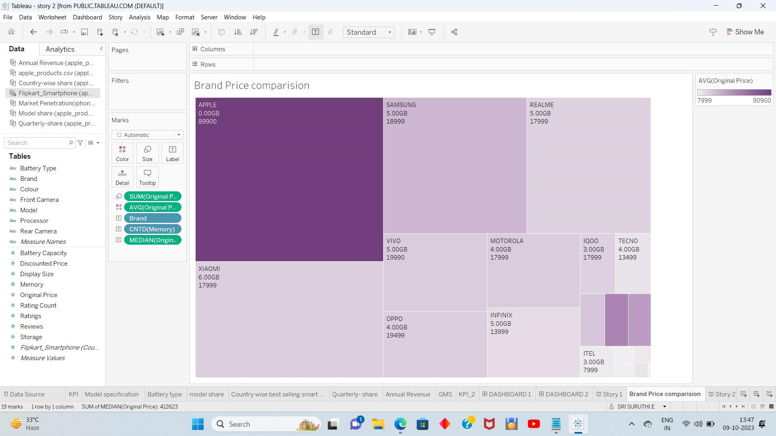
DASHBOARD 1
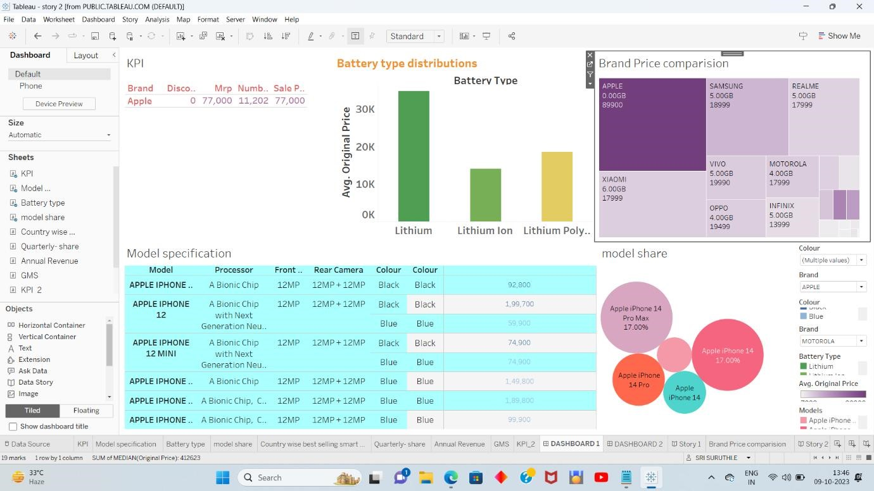
DASHBOARD 2
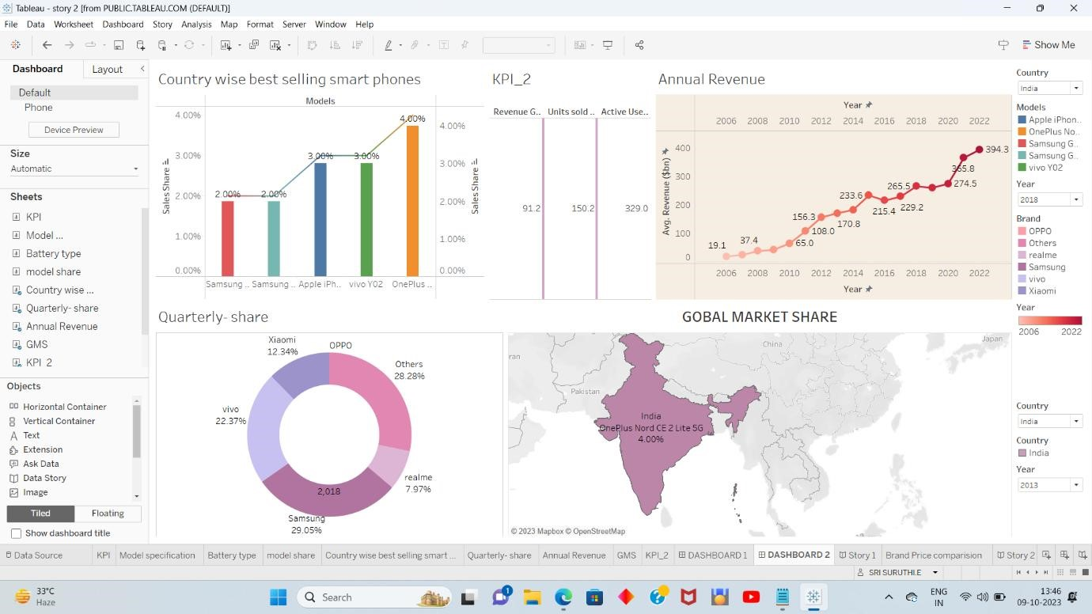
STORY 1
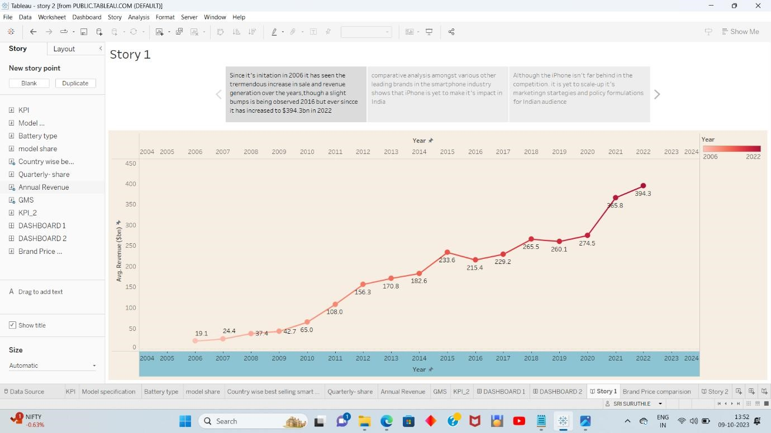
STORY 2
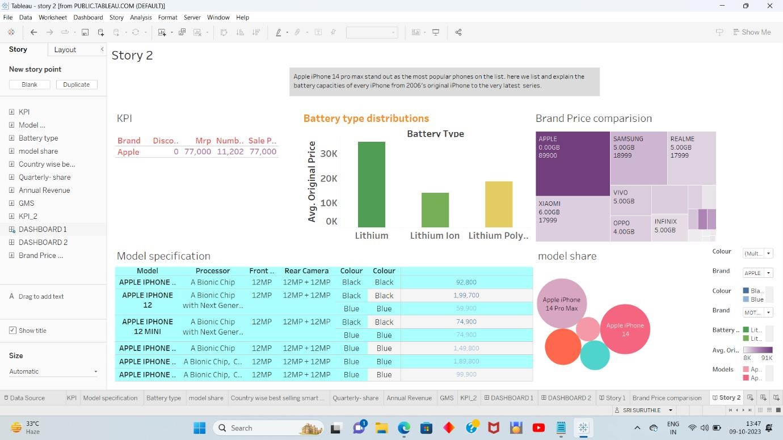

4. ADVANTAGES & DISADVANTAGES
4.1 ADVANTAGES:
- Apple iPhone manufacture in India can help the company save costs, tap into incentives, and access a large and growing market.
- Apple iPhone users in India can benefit from better deals, offers, and discounts on e-commerce sites and local stores
- Apple iPhone production in India can also create more jobs, boost the local economy, and reduce the dependence on China
- Apple iPhone innovation in India can also inspire more creativity, entrepreneurship, and social impact among the Indian youth.
4.2 DISADVANTAGES:
- The invention of the iPhone has affected people's lives and how they do things. It has also set in motion a few trends that wouldn't have been possible without iPhone. Apple has revolutionized communication, playing games, watching movies, listening to music, and more.
- Another disadvantage of iPhone is that they can be more prone to software and hardware restrictions compared to other smartphone brands.
- Another drawback of iPhone is that they have a closed ecosystem, which means they are less compatible with non-Apple devices and software.
- Another disadvantage of iPhone is that they tend to have shorter battery life compared to some other smartphones.

5. APPLICATION
- The impact of iPhone in India has been significant. They have revolutionized the smartphone market and brought advanced technology to the masses. iPhones have transformed the way people communicate, work, and access information. They have also contributed to the growth of the app economy and digital services in the country.
- The impact of iPhone in India has been tremendous. They have transformed the way people communicate, work, and access information. iPhone have also contributed to the growth of the app economy and digital services in the country. With their advanced features and user-friendly interface, iPhone have become a popular choice among Indian consumers. They have opened up new possibilities for entertainment, productivity, and connectivity.iPhone have had a significant impact in India. They have brought advanced technology to people's fingertips, enabling them to stay connected, access information, and enjoy various services. With a wide range of apps available, iPhone have transformed the way people work, communicate, and entertain themselves. They have become a symbol of status and aspiration for many in India. The popularity of iPhone continues to grow, shaping the digital landscape of the country.
- iPhones have had a significant impact in India.They have transformed the way people communicate, work, and access information. With a wide range of apps available, iPhone have become a popular choice for entertainment, productivity, and connectivity. They have also contributed to the growth of the app economy in India.

6. CONCLUSION
The world has changed as a consequence of the increasing use of smartphones, which have improved communication, connected people, and revolutionized many different businesses. With its main product, the iPhone, capturing markets around the world, Apple Inc. has emerged as a prominent player among the top smartphone makers. India, one of the economies with the greatest economic growth, has seen a tremendous increase in smartphone usage, making it an interesting market to study the effects of Apple's iPhone.
In order to shed light on important factors like market penetration, customer preferences, economic ramifications, and societal changes, this research report will perform a data-driven investigation of the impact of the iPhone in India. This study will offer invaluable insights into the trans formative impact of the iPhone on India's technological landscape and the lives of its consumers by using advanced data Analytics techniques and analyzing large datasets.
Apple has a special chance to increase its market share and develop a significant presence in India thanks to the country's large population and rising smartphone adoption. Each new iPhone model unveiling generates excitement and anticipation among Indian buyers. By utilizing the plethora of information
Already accessible, this research aims to go beyond conjecture and anecdotal evidence in order to develop a thorough knowledge of the effects of the iPhone.

7. FUTURE SCOPE
- The future scope of iPhone impact in India looks promising! With the growing smartphone market and increasing consumer demand, iPhone are expected to continue making a significant impact in India's tech scene.
- The future of iPhone in India is bright. With their advanced features, sleek design, and strong brand reputation, iPhone are likely to have a significant impact on the Indian market. They will continue to attract tech-savvy consumers and contribute to the growth of the smartphone industry in India.
- Definitely! i Phones have a strong presence in India and their impact is only expected to grow. With the increasing popularity of Apple products and the constant innovation in their features, iPhone will continue to be a sought-after choice for smartphone users in India. The future looks bright for iPhone enthusiasts!

.
- REFERENCE:
THE ECONOMICS TIMES -https://m.economictimes.com/industry/consproducts/electronics/iphone-15-a-look-at-apples-over-15-years-indiajourney-from-rs-31000-iphone-to-todays-masshysteria/amp_articleshow/103602816.cms
OUT LOOK -https://www.outlookindia.com/business/apple-iphone-15production-is-it-a-success-story-of-make-in-india-or-assemble-in-india-news-311466/amp
CASHIFY-https://www.cashify.in/manufacturing-apple-iphones-in-indiacustomer-benefit-price
- VIDEO
https://drive.google.com/file/d/1UG_G2v2PYStiQxNtnaE40Ri4ttgQERFk/vie w?usp=drivesdk

0

